name:Rohit Choudhary
Rollno:3011123078

Web service

Practical 1

tinyurl.com/tycs10001
Temperature Converter:-
Open Oracle Virtual Box:
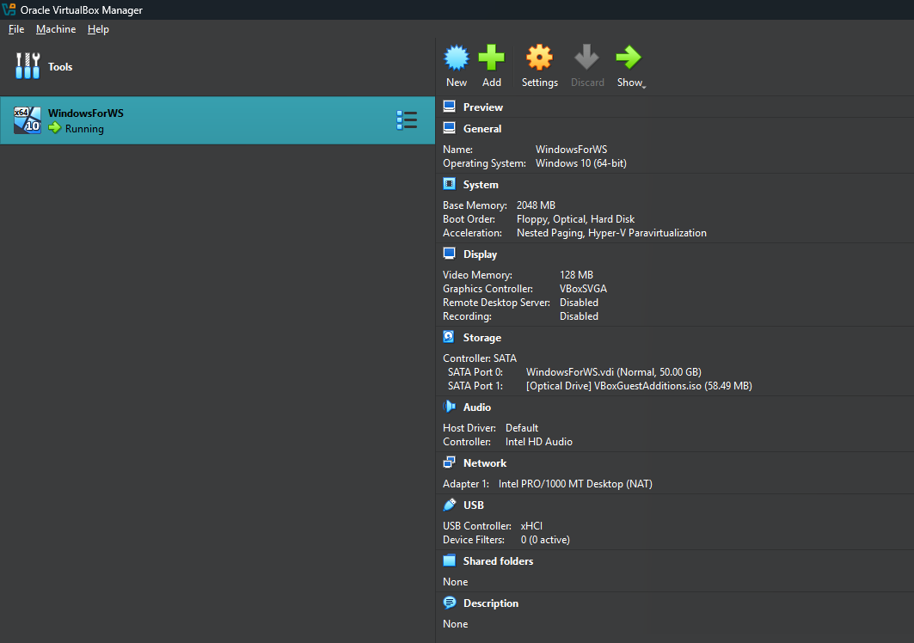
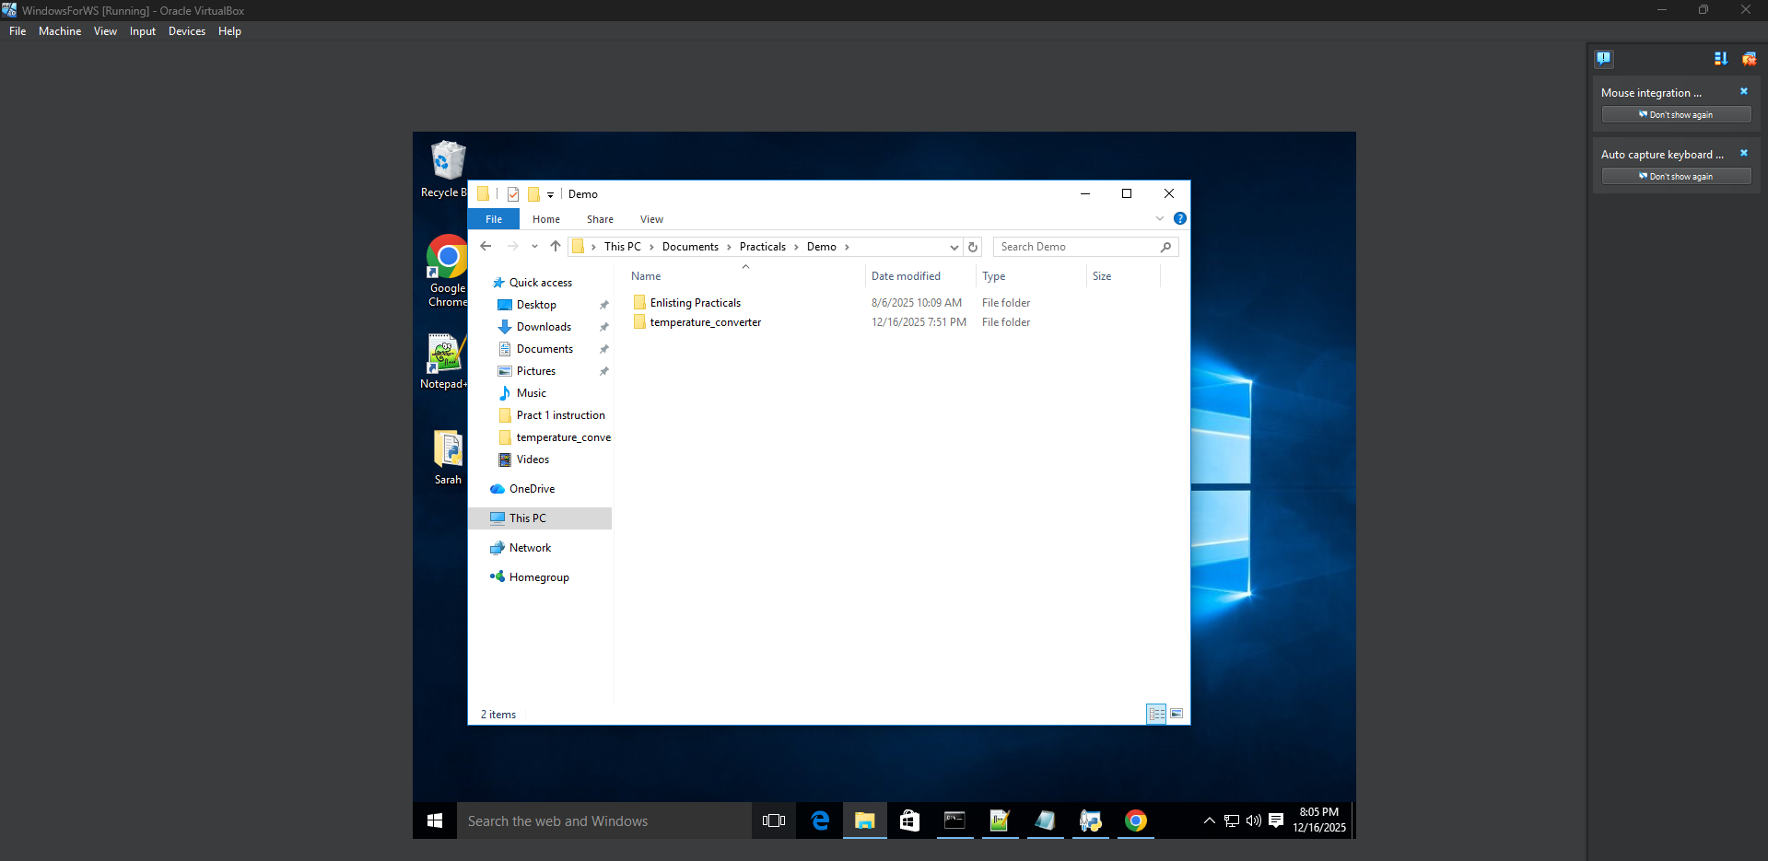
Instructions in VM:
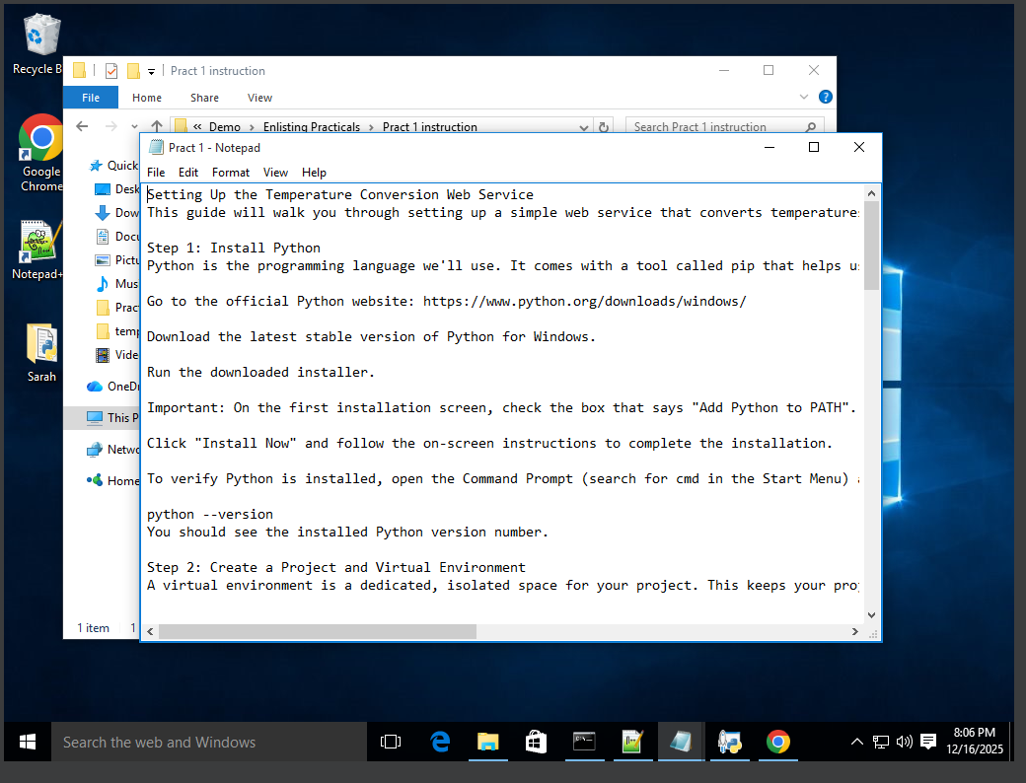
ctrl+X in different folder
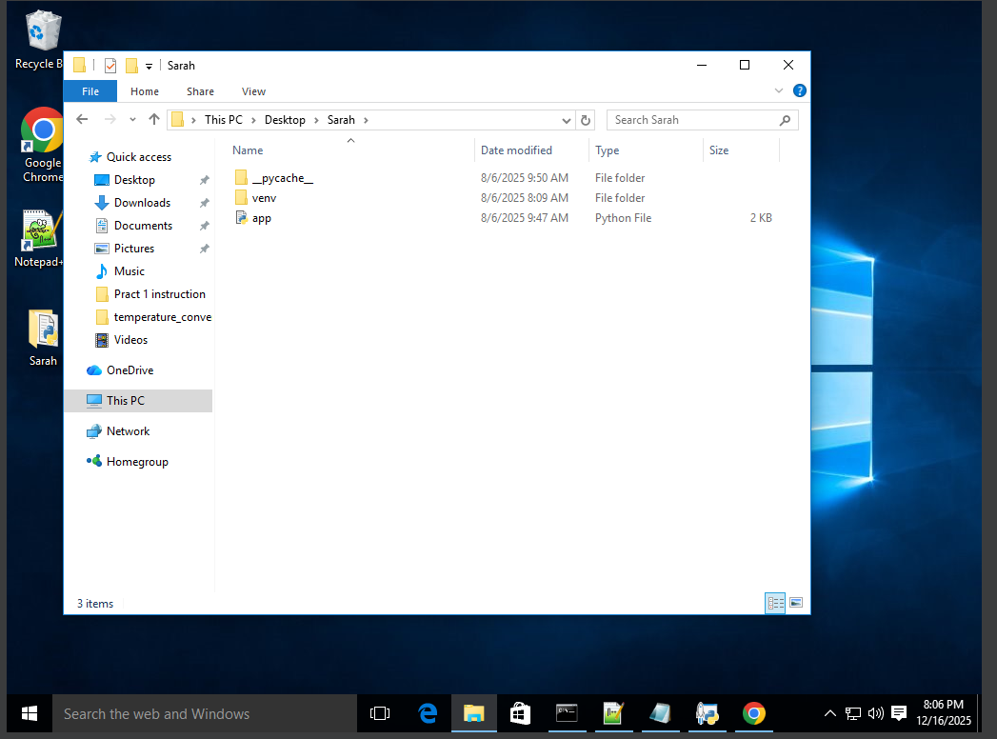
- python -m venv venv
- pip install Flask

Put the code in a Python file and save it
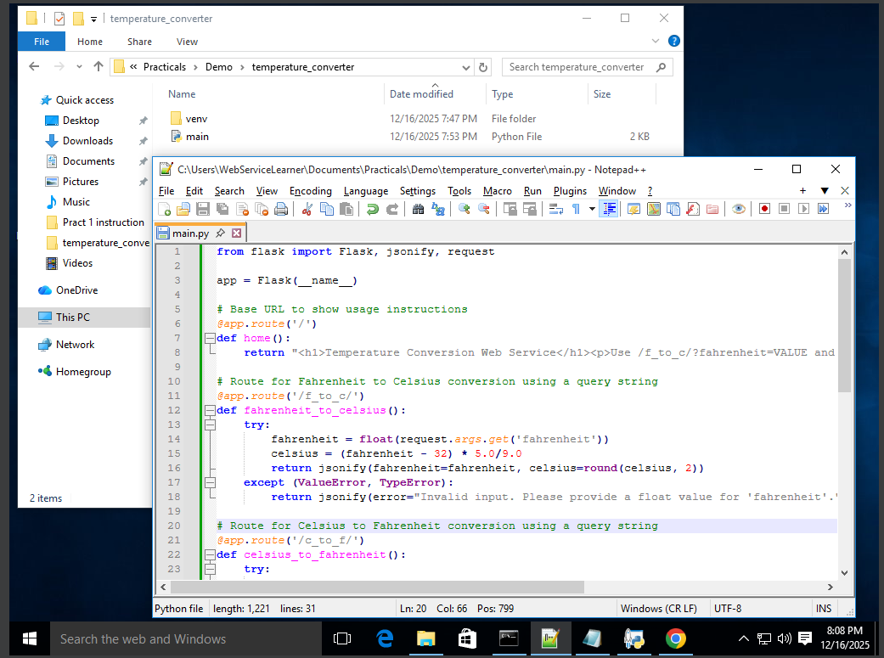

Then open the .py file and you’ll get this…copy the http and paste it in a browser.
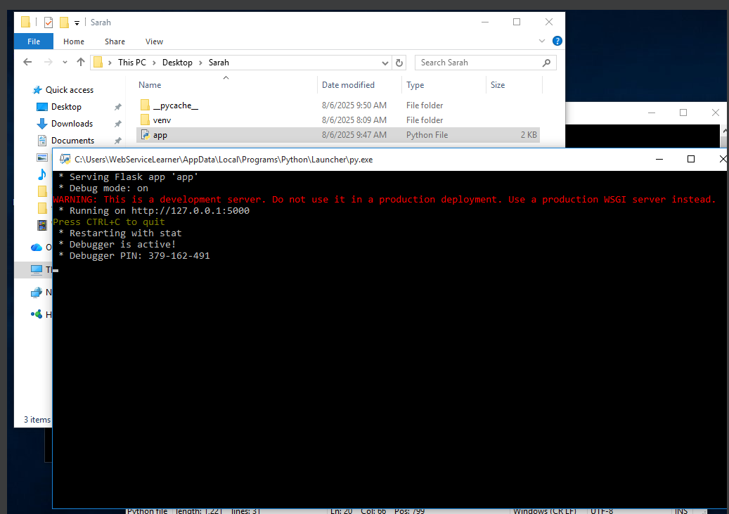
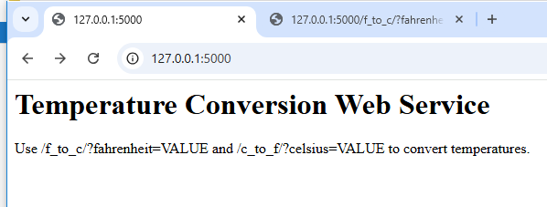
Then put a forward slash in the url and add this
/f_to_c/?fahrenheit=VALUE
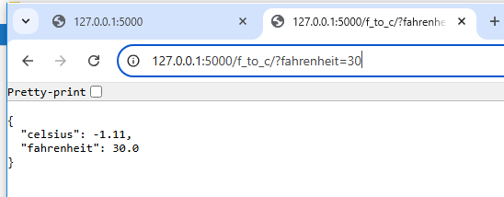
Your output is here!

Temperature converter code:-

from flask import Flask, jsonify, request

app = Flask(__name__)

# Base URL to show usage instructions
@app.route('/')
def home():
return "<h1>Temperature Conversion Web Service</h1><p>Use /f_to_c/?fahrenheit=VALUE and /c_to_f/?celsius=VALUE to convert temperatures.</p>"

# Route for Fahrenheit to Celsius conversion using a query string
@app.route('/f_to_c/')
def fahrenheit_to_celsius():
try:
fahrenheit = float(request.args.get('fahrenheit'))
celsius = (fahrenheit - 32) * 5.0/9.0
return jsonify(fahrenheit=fahrenheit, celsius=round(celsius, 2))
except (ValueError, TypeError):
return jsonify(error="Invalid input. Please provide a float value for 'fahrenheit'.")

# Route for Celsius to Fahrenheit conversion using a query string
@app.route('/c_to_f/')
def celsius_to_fahrenheit():
try:
celsius = float(request.args.get('celsius'))
fahrenheit = (celsius * 9.0/5.0) + 32
return jsonify(celsius=celsius, fahrenheit=round(fahrenheit, 2))
except (ValueError, TypeError):
return jsonify(error="Invalid input. Please provide a float value for 'celsius'.")

if __name__ == '__main__':
app.run(debug=True)

Part 2
Conversion from kilometer to miles and vise versa
Code:
from flask import Flask, jsonify, request

app = Flask(__name__)

# Base URL to show usage instructions
@app.route('/')
def home():
return "<h1>distance conversion Web Service</h1><p>Use /km_to_m/?kilometer=VALUE and /m_to_km/?miles=VALUE to convert distance.</p>"

# Route for kilometer to miles conversion using a query string
@app.route('/km_to_m//')
def kilometer_to_miles():
try:
kilometer = float(request.args.get('kilometer'))
miles = kilometer * 0.621371
return jsonify(kilometer=kilometer, miles=round(miles, 2))
except (ValueError, TypeError):
return jsonify(error="Invalid input. Please provide a float value for 'kilometer'.")

# Route for miles to kilometer conversion using a query string
@app.route('/miles_to_kilometer/')
def miles_to_kilometer():
try:
miles = float(request.args.get('miles'))
kilometer = miles / 0.621371
return jsonify(miles=miles, kilometer=round(kilometer, 2))
except (ValueError, TypeError):
return jsonify(error="Invalid input. Please provide a float value for 'miles'.")

if __name__ == '__main__':
app.run(debug=True)

Output
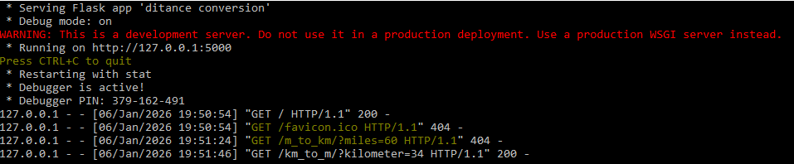
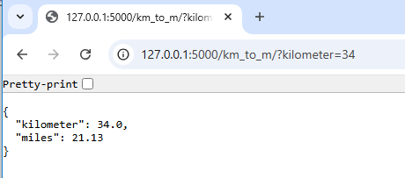

Part 3
Conversion from gigabytes to terabytes and vise versa
Code:
from flask import Flask, jsonify, request

app = Flask(__name__)

# Base URL to show usage instructions
@app.route('/')
def home():
return (
"<h1>Data Size Conversion Web Service</h1>"
"<p>Use /tb_to_gb/?tb=VALUE and /gb_to_tb/?gb=VALUE to convert data sizes.</p>"
)

# Route for Terabyte to Gigabyte conversion
@app.route('/tb_to_gb/')
def tb_to_gb():
try:
tb = float(request.args.get('tb'))
gb = tb * 1024
return jsonify(tb=tb, gb=round(gb, 2))
except (ValueError, TypeError):
return jsonify(error="Invalid input. Please provide a float value for 'tb'.")

# Route for Gigabyte to Terabyte conversion
@app.route('/gb_to_tb/')
def gb_to_tb():
try:
gb = float(request.args.get('gb'))
tb = gb / 1024
return jsonify(gb=gb, tb=round(tb, 4))
except (ValueError, TypeError):
return jsonify(error="Invalid input. Please provide a float value for 'gb'.")

if __name__ == '__main__':
app.run(debug=True)

Output:
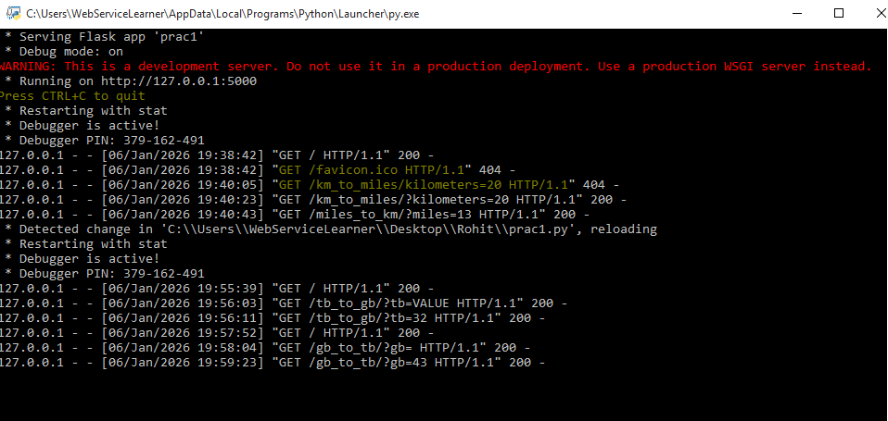
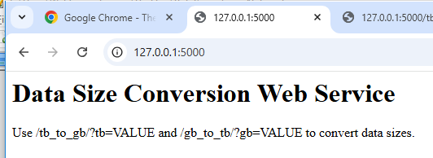
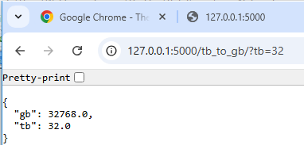

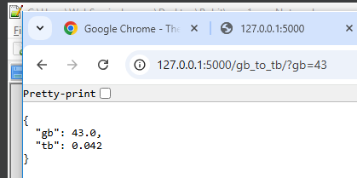

Part 4
Calculate bmi using height and weight
Code:

from flask import Flask, jsonify, request

app = Flask(__name__)

# Base URL to show usage instructions
@app.route('/')
def home():
return (

"<p>"
"BMI calculation:<br>"
"/bmi/?height=HEIGHT_IN_METERS&weight=WEIGHT_IN_KG"
"</p>"
)

# Route for Terabyte to Gigabyte conversion
@app.route('/bmi/')
def bmi():
try:
height = float(request.args.get('height')) # meters
weight = float(request.args.get('weight')) # kg

if height <= 0 or weight <= 0:
raise ValueError

bmi_value = weight / (height ** 2)

return jsonify(
height=height,
weight=weight,
bmi=round(bmi_value, 2)
)
except (ValueError, TypeError):
return jsonify(
error="Invalid input. Please provide height (meters) and weight (kg) as positive numbers."
)

if __name__ == '__main__':
app.run(debug=True)

Output:

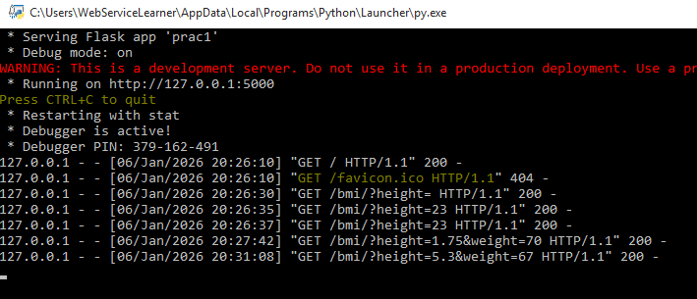

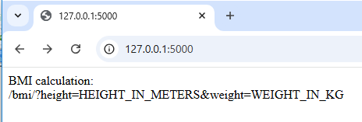

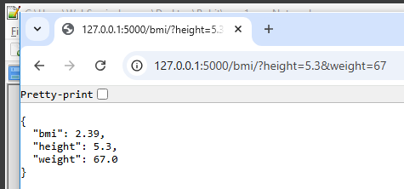

name:Rohit Choudhary
Rollno:3011123078

Web service

Practical 2

Setting Up an Arithmetic Web Service
Code:

from flask import Flask, jsonify, request

app = Flask(__name__)

# Base URL to show usage instructions
@app.route('/')
def home():
return "<h1>Arithmetic Web Service</h1><p>Use the following endpoints with query parameters (?num1=VALUE&num2=VALUE):</p><ul><li>/add</li><li>/subtract</li><li>/multiply</li><li>/divide</li></ul><p>Example: /add?num1=10&num2=5</p>"

def parse_numbers():
"""Helper function to parse num1 and num2 from request arguments."""
try:
num1 = float(request.args.get('num1'))
num2 = float(request.args.get('num2'))
return num1, num2
except (ValueError, TypeError):
return None, None # Indicate invalid input

@app.route('/add')
def add():
num1, num2 = parse_numbers()
if num1 is None or num2 is None:
return jsonify(error="Invalid input. Please provide valid float values for 'num1' and 'num2'."), 400
result = num1 + num2
return jsonify(operation="add", num1=num1, num2=num2, result=result)

@app.route('/subtract')
def subtract():
num1, num2 = parse_numbers()
if num1 is None or num2 is None:
return jsonify(error="Invalid input. Please provide valid float values for 'num1' and 'num2'."), 400
result = num1 - num2
return jsonify(operation="subtract", num1=num1, num2=num2, result=result)

@app.route('/multiply')
def multiply():
num1, num2 = parse_numbers()
if num1 is None or num2 is None:
return jsonify(error="Invalid input. Please provide valid float values for 'num1' and 'num2'."), 400
result = num1 * num2
return jsonify(operation="multiply", num1=num1, num2=num2, result=result)

@app.route('/divide')
def divide():
num1, num2 = parse_numbers()
if num1 is None or num2 is None:
return jsonify(error="Invalid input. Please provide valid float values for 'num1' and 'num2'."), 400
if num2 == 0:
return jsonify(error="Cannot divide by zero."), 400
result = num1 / num2
return jsonify(operation="divide", num1=num1, num2=num2, result=result)

if __name__ == '__main__':
app.run(debug=True)
Output:
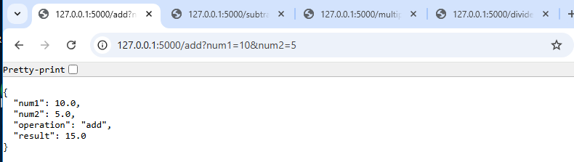
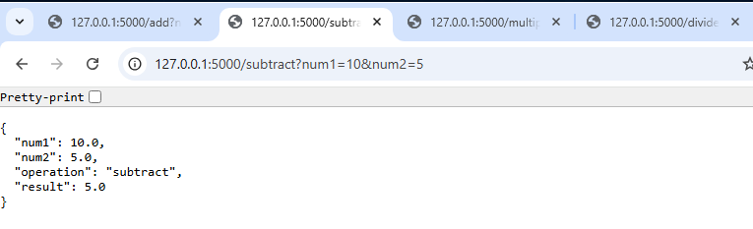
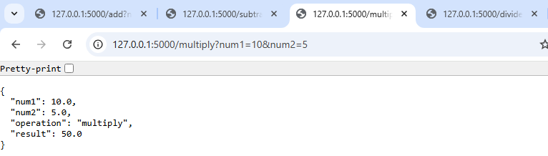
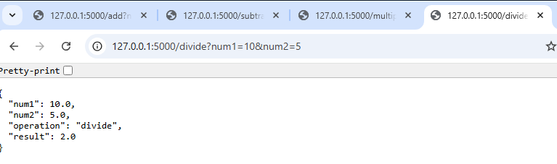

Name : Rohit Choudhary
Roll no: 31011123078
Practical No. 3
Title: Develop a Web Application Client Who Consumes Web Services
Aim
To create a Java application client that consumes a remote SOAP-based web service and displays the results.
Introduction
A web service client allows applications to access and use remote services over the internet. Example:
- Weather apps call remote weather services.
- Payment gateways call banking services.
- Calculator demo services perform arithmetic remotely.
In this practical, we will build a Java client program that calls a SOAP Calculator Web Service and displays results.
Requirements
•
Windows 10 or later
•
Java Development Kit (JDK 8 recommended)
•
Command Prompt
•
Internet Browser
•
Apache Tomcat (optional, if using servlet-based client)
•
Sample WSDL: http://www.dneonline.com/calculator.asmx?WSDL
Download Links
•
JDK 8 (Windows x64 installer):
https://cfdownload.adobe.com/pub/adobe/coldfusion/java/java8/java8u441/jdk/jdk-8u441- windows-x64.exe
•
Apache Tomcat 8.5.100 (zip file):
http://archive.apache.org/dist/tomcat/tomcat-8/v8.5.100/bin/apache-tomcat-8.5.100-windows x64.zip
1
Step 1: Install & Configure JDK 8 1. Install JDK
•
Run the downloaded installer.
•
Keep clicking Next → Next → Finish. •
Default install path:
C:\Program Files\Java\jdk1.8.0_441
2. Set Environment Variables (baby steps) We must set JAVA_HOME and add bin folder to PATH.
1. 2.
Find JDK path:
Open File Explorer → go to C:\Program Files\Java\ → find jdk1.8.0_441 .
3.
Copy the full path (e.g., C:\Program Files\Java\jdk1.8.0_441 ).
4.
Open Environment Variables:
5.
Press Windows key → type Edit the system environment variables → press Enter. 6.
In System Properties → click Environment Variables….
7.
Add JAVA_HOME:
8. 9.
Under System Variables → click New….
Variable name: JAVA_HOME
10.
Variable value: C:\Program Files\Java\jdk1.8.0_441
11.
Click OK.
12.
Add to PATH:
13.
Still in System Variables → find Path → click Edit.
14.
If you see a list view → click New, type:
%JAVA_HOME%\bin
Then move it UP to the top.
15.
If you see a single-line box → add this at the very start of the line: %JAVA_HOME%\bin;
2
Remove old/duplicate Java paths (like C:\Program Files (x86)\Common
16.
Files\Oracle\Java\java8path ).
17.
Save changes: Click OK → OK → OK.
18.
Open new Command Prompt (important!) and check:
echo %JAVA_HOME%
java -version
javac -version
wsimport -version
Expected output:
C:\Program Files\Java\jdk1.8.0_441
java version "1.8.0_441"
javac 1.8.0_441
JAX-WS RI 2.2.x
If all good → success
If not → recheck JAVA_HOME and PATH.
Step 2: Install & Configure Tomcat (Optional for Servlet Version)
1. 2.
Extract the Tomcat zip to: C:\apache-tomcat
Add CATALINA_HOME:
3.
In Environment Variables → System Variables → New…
4. 5.
Name: CATALINA_HOME
Value: C:\apache-tomcat
6.
Add to PATH:
3
7. 8.
Edit Path → add:
%CATALINA_HOME%\bin
Test Tomcat:
echo %CATALINA_HOME%
dir "%CATALINA_HOME%\bin\startup.bat"
cd /d %CATALINA_HOME%\bin
startup.bat
Open in browser: http://localhost:8080
If dir cannot find startup.bat , re-extract Tomcat so that C:\apache-tomcat\bin\startup.bat exists.
Step 3: Prepare Project Folder
Create folder structure step by step:
mkdir C:\Practical4
mkdir C:\Practical4\src
mkdir C:\Practical4\classes
mkdir C:\Practical4\webapp
mkdir C:\Practical4\webapp\WEB-INF
mkdir C:\Practical4\webapp\WEB-INF\classes
mkdir C:\Practical4\webapp\WEB-INF\lib
Now you have:
C:\Practical4
├─ src
├─ classes
└─ webapp\WEB-INF\classes
4
Step 4: Generate SOAP Client Stubs Run in CMD:
cd C:\Practical4\src
wsimport -keep -p calculator http://www.dneonline.com/calculator.asmx?WSDL
•
-keep → keeps Java files.
•
-p calculator → puts them in package calculator .
If no internet, save WSDL locally and run:
wsimport -keep -p calculator file:///C:/Practical4/src/calculator.wsdl This generates files in:
C:\Practical4\src\calculator
Step 5: Create Console Client Program File: C:\Practical4\src\CalculatorClient.java
import calculator.Calculator;
import calculator.CalculatorSoap;
public class CalculatorClient {
public static void main(String[] args) {
Calculator service = new Calculator();
CalculatorSoap port = service.getCalculatorSoap();
int sum = port.add(10, 20);
int mul = port.multiply(5, 6);
System.out.println("10 + 20 = " + sum);
System.out.println("5 * 6 = " + mul);
}
}
5
Step 6: Compile & Run Console Client Compile:
cd C:\Practical4\src
javac -d ..\classes CalculatorClient.java calculator\*.java
Run:
cd ..\classes
java CalculatorClient
Expected Output:
10 + 20 = 30
5 * 6 = 30
Step 7: (Optional) Servlet Version with Tomcat
1. Add index.jsp
File: C:\Practical4\webapp\index.jsp
<html><body>
<h2>SOAP Calculator</h2>
<form action="calc" method="get">
A: <input name="a" value="10"/> &nbsp;
B: <input name="b" value="15"/> &nbsp;
<input type="submit" value="Calculate"/>
</form>
</body></html>
2. Add web.xml
File: C:\Practical4\webapp\WEB-INF\web.xml
6
<web-app xmlns="http://xmlns.jcp.org/xml/ns/javaee"
xmlns:xsi="http://www.w3.org/2001/XMLSchema-instance"
xsi:schemaLocation="http://xmlns.jcp.org/xml/ns/javaee
http://xmlns.jcp.org/xml/ns/javaee/web-app_3_1.xsd" version="3.1">
<servlet>
<servlet-name>CalcServlet</servlet-name>
<servlet-class>yourapp.CalculatorServlet</servlet-class>
</servlet>
<servlet-mapping>
<servlet-name>CalcServlet</servlet-name>
<url-pattern>/calc</url-pattern>
</servlet-mapping>
<welcome-file-list>
<welcome-file>index.jsp</welcome-file>
</welcome-file-list>
</web-app>
3. Create Servlet
File: C:\Practical4\src\yourapp\CalculatorServlet.java
package yourapp;
import calculator.Calculator;
import calculator.CalculatorSoap;
import java.io.IOException;
import javax.servlet.ServletException;
import javax.servlet.http.*;
public class CalculatorServlet extends HttpServlet {
@Override
protected void doGet(HttpServletRequest req, HttpServletResponse resp) throws ServletException, IOException {
resp.setContentType("text/html;charset=UTF-8");
try {
int a = Integer.parseInt(req.getParameter("a"));
int b = Integer.parseInt(req.getParameter("b"));
Calculator service = new Calculator();
CalculatorSoap port = service.getCalculatorSoap();
int result = port.add(a, b);
7
resp.getWriter().println("<html><body>");
resp.getWriter().printf("%d + %d = %d", a, b, result);
resp.getWriter().println("</body></html>");
} catch (Exception e) {
e.printStackTrace(resp.getWriter());
}
}
}
4. Compile and place classes
cd C:\Practical4
javac -d webapp\WEB-INF\classes src\calculator\*.java
javac -cp "%CATALINA_HOME%\lib\servlet-api.jar;webapp\WEB-INF\classes" -d webapp\WEB-INF\classes src\yourapp\CalculatorServlet.java
5. Package WAR and deploy
cd C:\Practical4\webapp
jar -cvf calcapp.war *
copy calcapp.war %CATALINA_HOME%\webapps
6. Start Tomcat and test
cd %CATALINA_HOME%\bin
startup.bat
Browser: - http://localhost:8080/calcapp/ - http://localhost:8080/calcapp/calc?a=10&b=20 Troubleshooting (Most Common Issues)
•
java not recognized → PATH not set, recheck %JAVA_HOME%\\bin .
•
javac or wsimport not recognized → you are running with an Oracle shim (like C:\Program Files (x86)\Common Files\Oracle\Java\java8path ). Remove it from PATH and ensure %JAVA_HOME%\\bin is first.
•
wsimport missing even after fixing PATH → Wrong JDK (you installed JRE). Install JDK 8 from the
link.
•
CATALINA_HOME not working → Path wrong or Tomcat not extracted. Verify: 8
echo %CATALINA_HOME%
dir "%CATALINA_HOME%\bin\startup.bat" •
404 error → WAR not deployed correctly.
•
500 error → Servlet code/runtime error. Check catalina.log .
•
Port 8080 busy → Change port in C:\apache-tomcat\\conf\\server.xml .
Final Deliverables
1.
Console Client: CalculatorClient.java + screenshot of output.
2.
Servlet Client (optional): Servlet code, web.xml , screenshot of browser output. 3.
Short write-up: This program consumes a SOAP web service to perform remote addition/multiplication.
Pre-Lab Checklist
Before starting with students:
- Run these on each PC:
echo %JAVA_HOME%
java -version
javac -version
wsimport -version
echo %CATALINA_HOME%
dir "%CATALINA_HOME%\bin\startup.bat"
- Confirm JDK 8 + wsimport works.
- Confirm Tomcat starts on port 8080.
Quick Checklist for Students
1.
Install JDK 8.
2.
Add JAVA_HOME = C:\Program Files\Java\jdk1.8.0_441 .
3.
Add %JAVA_HOME%\\bin to Path.
4.
Install Tomcat (optional). Add CATALINA_HOME = C:\apache-tomcat .
5.
Verify with java -version , javac -version , wsimport -version .
6.
Generate stubs with wsimport .
7.
Write, compile, and run CalculatorClient.java .
8.
(Optional) Package servlet webapp and deploy to Tomcat.
Execution:
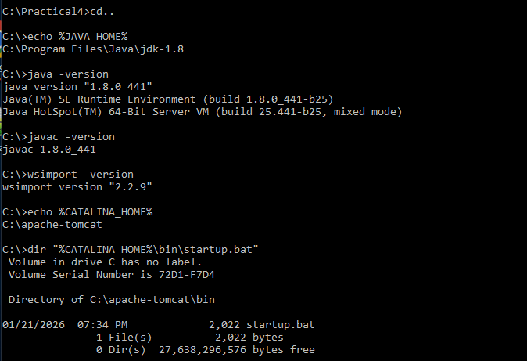
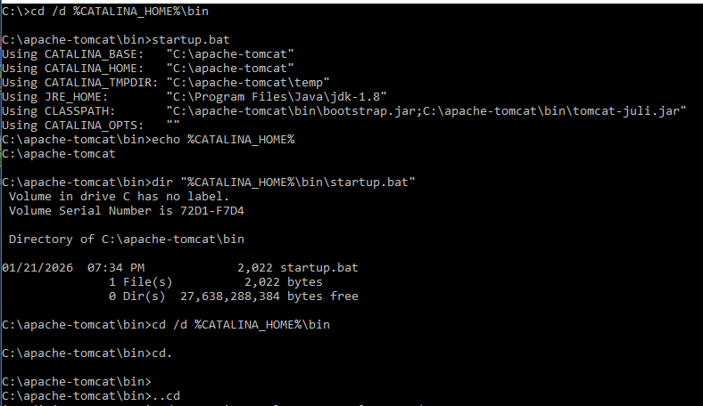
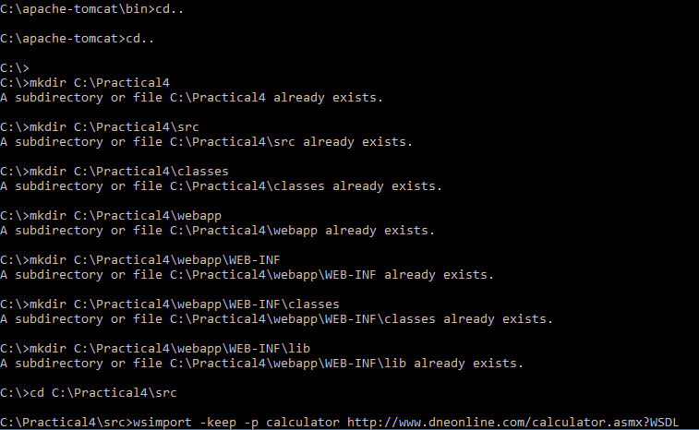
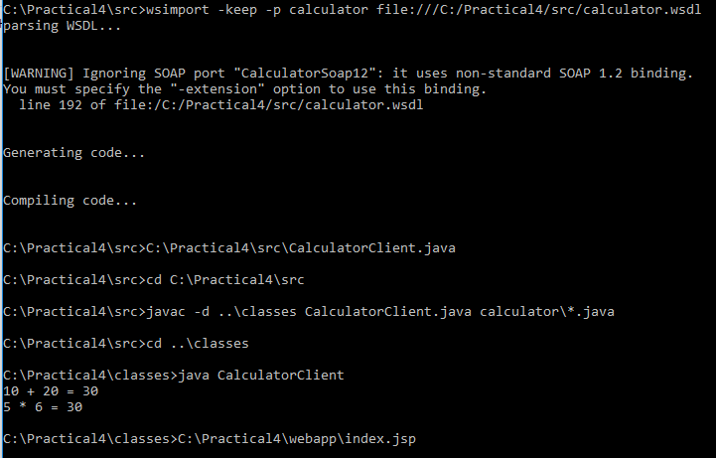
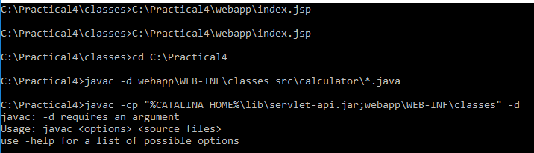
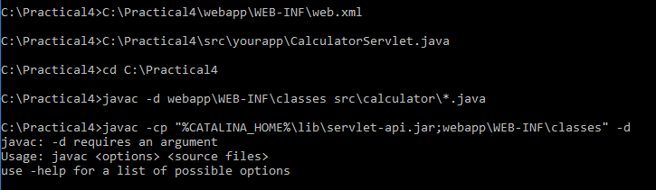
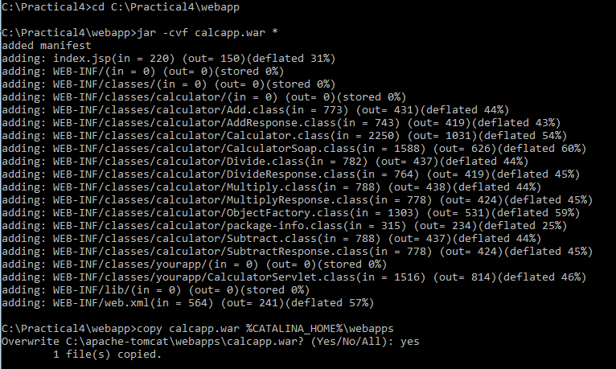
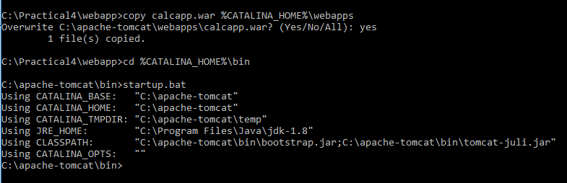
Output :
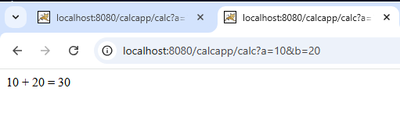
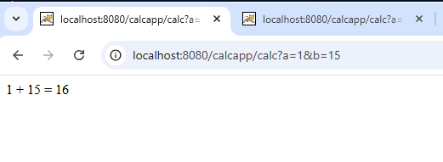

Name: Rohit Choudhary
Roll no:31011123078
TYCS
Practical No. 4

Title
Develop a Desktop Application Client Who Consumes Web Services

Objective
To create a small Java desktop (Swing) application that consumes both a SOAP web service
and a REST web service. The application demonstrates interoperability across different
platforms.

Learning Outcomes
After completing this practical, you will be able to:
1. Explain SOAP, WSDL, and REST concepts.
2. Use wsimport to generate SOAP client stubs from WSDL.
3. Build a simple Swing desktop GUI application.
4. Invoke a SOAP operation and display results.
5. Invoke a REST API endpoint and display JSON response (random dog image).
6. Resolve common errors related to PATH, wsimport, and connectivity.
Concepts Recap
• SOAP: Protocol using XML over HTTP.
• WSDL: Contract file describing SOAP service operations.
• wsimport: Tool in JDK 8 to generate proxy classes from WSDL.
• REST: Web API style using HTTP and JSON.
• Swing: Java GUI toolkit for desktop applications.

Requirements
- Windows 10 or later
- JDK 8 installed with java, javac, wsimport
- Internet connection (for REST API)

- Local WSDL copy for SOAP (calculator.wsdl)
- Command Prompt or IDE

Step-by-Step Instructions
Step 1 — Create folders
mkdir C:\Practical4
cd C:\Practical4
mkdir src
mkdir classes
Step 2 — Save WSDL file locally
1. Open in browser: http://www.dneonline.com/calculator.asmx?WSDL
2. Save as calculator.wsdl inside: C:\Practical5\src
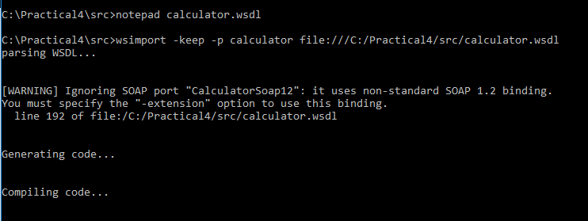
Step 3 — Generate SOAP stubs
cd C:\Practical4\src
wsimport -keep -p calculator file:///C:/Practical5/src/calculator.wsdl
Step 4 — Create Java application
Create C:\Practical4\src\MiniClient.java and paste the following code:
import javax.swing.*;
import java.awt.*;
import java.net.*;
import calculator.Calculator;
import calculator.CalculatorSoap;
public class MiniClient {
static String http(String u) throws Exception {
java.util.Scanner s = new java.util.Scanner(new URL(u).openStream(), &quot;UTF-8&quot;);
String r = s.useDelimiter(&quot;\\A&quot;).next(); s.close(); return r;
}
static String dogUrl() throws Exception {
String j = http(&quot;https://dog.ceo/api/breeds/image/random&quot;);
return j.split(&quot;\&quot;message\&quot;:\&quot;&quot;)[1].split(&quot;\&quot;&quot;)[0].replace(&quot;\\/&quot;, &quot;/&quot;);
}
public static void main(String[] a) throws Exception {
Calculator c = new Calculator();
int sum = c.getCalculatorSoap().add(5,7);
JFrame f = new JFrame(&quot;Practical 5 — SOAP 5+7 = &quot; + sum);
JLabel img = new JLabel(&quot;Click the button to load a dog ��&quot;, SwingConstants.CENTER);

JButton b = new JButton(&quot;Fetch Dog&quot;);
f.add(img, BorderLayout.CENTER); f.add(b, BorderLayout.SOUTH);
f.setSize(500,400); f.setLocationRelativeTo(null);
f.setDefaultCloseOperation(JFrame.EXIT_ON_CLOSE); f.setVisible(true);
b.addActionListener(e -&gt; {
try {
img.setText(&quot;Loading...&quot;);
String u = dogUrl();
img.setIcon(new ImageIcon(new URL(u)));
img.setText(null);
} catch (Exception ex) {
img.setText(&quot;Failed to load image&quot;);
}
});
}
}
Step 5 — Compile
cd C:\Practical4\src

javac -d ..\classes MiniClient.java calculator\*.java
Step 6 — Run

cd ..\classes

java MiniClient
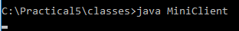

Expected Output
- Window title: Practical 4 — SOAP 5+7 = 12
- UI with a button: Fetch Dog
- On click → Random dog image appears.
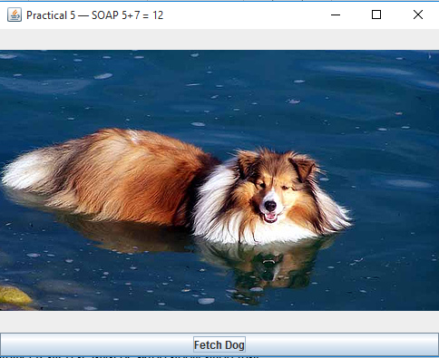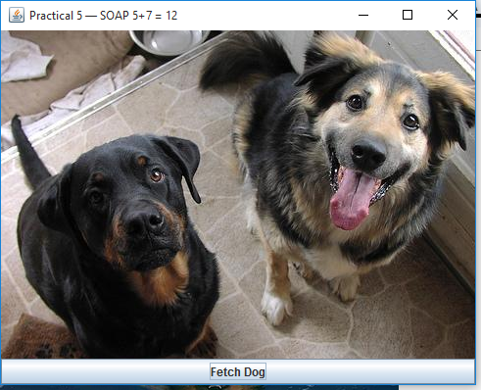

Troubleshooting
• wsimport not recognized → JDK 8 not in PATH.
• directory not found: ..\classes → Create it: mkdir C:\Practical5\classes
• Error: Could not find or load main class MiniClient → Run from C:\Practical5\classes
• Image not loading → Check internet connection.

Conclusion
You successfully created a Java desktop application that:
- Consumes a SOAP service (Calculator Add method)
- Consumes a REST API (Dog CEO random image)
This demonstrates cross-platform interoperability and introduces practical use of SOAP +
REST in a single application.

Name: Rohit Choudhary
Roll no:31011123078
TYCS
Practical No. 5
Title
Develop a Servlet that Consumes a Web Service (HTTP Cat API)
Objective
To develop a simple Java Servlet that consumes a REST web service using the HTTP Cat API. The servlet displays cat images corresponding to HTTP status codes.
Learning Outcomes
After completing this practical, you will be able to:
1. Create and configure a basic Java Servlet.
2. Understand how Servlets can consume REST services.
3. Use query parameters to pass data to a Servlet.
4. Deploy Servlets on Apache Tomcat.
5. Debug common issues with servlet compilation and deployment.
Requirements
- Windows 10 or later
- JDK 8 installed (java, javac)
- Apache Tomcat installed (8.x or 9.x)
- Basic knowledge of Servlet folder structure (WEB-INF, classes, web.xml)
Step-by-Step Instructions
Step 1 — Create Project Structure
C:\Practical5
C:\Practical5\WEB-INF
C:\Practical5\WEB-INF\classes
C:\Practical5\WEB-INF\lib
Step 2 — Create Servlet Code
File: C:\Practical5\WEB-INF\classes\HttpCatServlet.java
import java.io.*;
import javax.servlet.*;
import javax.servlet.http.*;
public class HttpCatServlet extends HttpServlet {
@Override
protected void doGet(HttpServletRequest req, HttpServletResponse resp) throws ServletException, IOException {
resp.setContentType("text/html;charset=UTF-8");
PrintWriter out = resp.getWriter();
String code = req.getParameter("code");
if (code == null) code = "404";
String imgUrl = "https://http.cat/" + code;
out.println("<html><body style='text-align:center;'>");
out.println("<h2>HTTP Cat Demo — Code " + code + "</h2>");
out.println("<img src='" + imgUrl + "' alt='Cat for " + code + "' width='500'><br>"); out.println("<p>Try changing the code in the URL: "
+ "<a href='?code=200'>200</a>, "
+ "<a href='?code=503'>503</a>, "
+ "<a href='?code=418'>418</a></p>");
out.println("</body></html>");
}
}
Step 3 — Create web.xml
<web-app xmlns="http://java.sun.com/xml/ns/javaee" version="3.0"> <servlet>
<servlet-name>HttpCatServlet</servlet-name>
<servlet-class>HttpCatServlet</servlet-class>
</servlet>
<servlet-mapping>
<servlet-name>HttpCatServlet</servlet-name>
<url-pattern>/cat</url-pattern>
</servlet-mapping>
</web-app>
Step 4 — Compile Servlet
cd C:\Practical5\WEB-INF\classes
javac -cp ".;C:\apache-tomcat\lib\*" HttpCatServlet.java
Step 5 — Deploy
Copy the C:\Practical5 folder into C:\apache-tomcat\webapps Start Tomcat: C:\apache-tomcat\bin\startup.bat
Step 6 — Run in Browser
http://localhost:8080/Practical5/cat?code=200 http://localhost:8080/Practical5/cat?code=404 http://localhost:8080/Practical5/cat?code=503
Expected Output
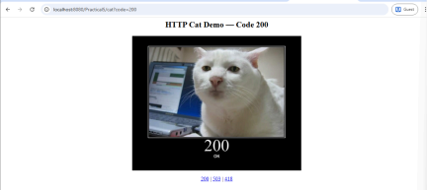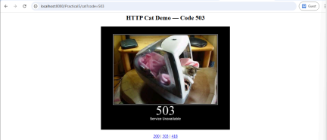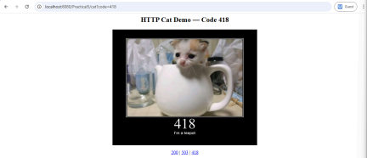
Conclusion
You created a Java Servlet that consumes a REST API (HTTP Cat) and dynamically displays images based on HTTP status codes. This demonstrates how Servlets can integrate with external web services and provide dynamic web content.

Name: Rohit Choudhary
Roll no:31011123078
TYCS
Practical No. 4

Title
Develop a Desktop Application Client Who Consumes Web Services

Objective
To create a small Java desktop (Swing) application that consumes both a SOAP web service
and a REST web service. The application demonstrates interoperability across different
platforms.

Learning Outcomes
After completing this practical, you will be able to:
1. Explain SOAP, WSDL, and REST concepts.
2. Use wsimport to generate SOAP client stubs from WSDL.
3. Build a simple Swing desktop GUI application.
4. Invoke a SOAP operation and display results.
5. Invoke a REST API endpoint and display JSON response (random dog image).
6. Resolve common errors related to PATH, wsimport, and connectivity.
Concepts Recap
• SOAP: Protocol using XML over HTTP.
• WSDL: Contract file describing SOAP service operations.
• wsimport: Tool in JDK 8 to generate proxy classes from WSDL.
• REST: Web API style using HTTP and JSON.
• Swing: Java GUI toolkit for desktop applications.

Requirements
- Windows 10 or later
- JDK 8 installed with java, javac, wsimport
- Internet connection (for REST API)

- Local WSDL copy for SOAP (calculator.wsdl)
- Command Prompt or IDE

Step-by-Step Instructions
Step 1 — Create folders
mkdir C:\Practical4
cd C:\Practical4
mkdir src
mkdir classes
Step 2 — Save WSDL file locally
1. Open in browser: http://www.dneonline.com/calculator.asmx?WSDL
2. Save as calculator.wsdl inside: C:\Practical5\src

Step 3 — Generate SOAP stubs
cd C:\Practical4\src
wsimport -keep -p calculator file:///C:/Practical5/src/calculator.wsdl
Step 4 — Create Java application
Create C:\Practical4\src\MiniClient.java and paste the following code:
import javax.swing.*;
import java.awt.*;
import java.net.*;
import calculator.Calculator;
import calculator.CalculatorSoap;
public class MiniClient {
static String http(String u) throws Exception {
java.util.Scanner s = new java.util.Scanner(new URL(u).openStream(), &quot;UTF-8&quot;);
String r = s.useDelimiter(&quot;\\A&quot;).next(); s.close(); return r;
}
static String dogUrl() throws Exception {
String j = http(&quot;https://dog.ceo/api/breeds/image/random&quot;);
return j.split(&quot;\&quot;message\&quot;:\&quot;&quot;)[1].split(&quot;\&quot;&quot;)[0].replace(&quot;\\/&quot;, &quot;/&quot;);
}
public static void main(String[] a) throws Exception {
Calculator c = new Calculator();
int sum = c.getCalculatorSoap().add(5,7);
JFrame f = new JFrame(&quot;Practical 5 — SOAP 5+7 = &quot; + sum);
JLabel img = new JLabel(&quot;Click the button to load a dog ��&quot;, SwingConstants.CENTER);

JButton b = new JButton(&quot;Fetch Dog&quot;);
f.add(img, BorderLayout.CENTER); f.add(b, BorderLayout.SOUTH);
f.setSize(500,400); f.setLocationRelativeTo(null);
f.setDefaultCloseOperation(JFrame.EXIT_ON_CLOSE); f.setVisible(true);
b.addActionListener(e -&gt; {
try {
img.setText(&quot;Loading...&quot;);
String u = dogUrl();
img.setIcon(new ImageIcon(new URL(u)));
img.setText(null);
} catch (Exception ex) {
img.setText(&quot;Failed to load image&quot;);
}
});
}
}
Step 5 — Compile
cd C:\Practical4\src

javac -d ..\classes MiniClient.java calculator\*.java
Step 6 — Run

cd ..\classes

java MiniClient


Expected Output
- Window title: Practical 4 — SOAP 5+7 = 12
- UI with a button: Fetch Dog
- On click → Random dog image appears.


Troubleshooting
• wsimport not recognized → JDK 8 not in PATH.
• directory not found: ..\classes → Create it: mkdir C:\Practical5\classes
• Error: Could not find or load main class MiniClient → Run from C:\Practical5\classes
• Image not loading → Check internet connection.

Conclusion
You successfully created a Java desktop application that:
- Consumes a SOAP service (Calculator Add method)
- Consumes a REST API (Dog CEO random image)
This demonstrates cross-platform interoperability and introduces practical use of SOAP +
REST in a single application.

Name: Rohit Choudhary
Roll no:31011123078
TYCS
Practical No. 5
Title
Develop a Servlet that Consumes a Web Service (HTTP Cat API)
Objective
To develop a simple Java Servlet that consumes a REST web service using the HTTP Cat API. The servlet displays cat images corresponding to HTTP status codes.
Learning Outcomes
After completing this practical, you will be able to:
1. Create and configure a basic Java Servlet.
2. Understand how Servlets can consume REST services.
3. Use query parameters to pass data to a Servlet.
4. Deploy Servlets on Apache Tomcat.
5. Debug common issues with servlet compilation and deployment.
Requirements
- Windows 10 or later
- JDK 8 installed (java, javac)
- Apache Tomcat installed (8.x or 9.x)
- Basic knowledge of Servlet folder structure (WEB-INF, classes, web.xml)
Step-by-Step Instructions
Step 1 — Create Project Structure
C:\Practical5
C:\Practical5\WEB-INF
C:\Practical5\WEB-INF\classes
C:\Practical5\WEB-INF\lib
Step 2 — Create Servlet Code
File: C:\Practical5\WEB-INF\classes\HttpCatServlet.java
import java.io.*;
import javax.servlet.*;
import javax.servlet.http.*;
public class HttpCatServlet extends HttpServlet {
@Override
protected void doGet(HttpServletRequest req, HttpServletResponse resp) throws ServletException, IOException {
resp.setContentType("text/html;charset=UTF-8");
PrintWriter out = resp.getWriter();
String code = req.getParameter("code");
if (code == null) code = "404";
String imgUrl = "https://http.cat/" + code;
out.println("<html><body style='text-align:center;'>");
out.println("<h2>HTTP Cat Demo — Code " + code + "</h2>");
out.println("<img src='" + imgUrl + "' alt='Cat for " + code + "' width='500'><br>"); out.println("<p>Try changing the code in the URL: "
+ "<a href='?code=200'>200</a>, "
+ "<a href='?code=503'>503</a>, "
+ "<a href='?code=418'>418</a></p>");
out.println("</body></html>");
}
}
Step 3 — Create web.xml
<web-app xmlns="http://java.sun.com/xml/ns/javaee" version="3.0"> <servlet>
<servlet-name>HttpCatServlet</servlet-name>
<servlet-class>HttpCatServlet</servlet-class>
</servlet>
<servlet-mapping>
<servlet-name>HttpCatServlet</servlet-name>
<url-pattern>/cat</url-pattern>
</servlet-mapping>
</web-app>
Step 4 — Compile Servlet
cd C:\Practical5\WEB-INF\classes
javac -cp ".;C:\apache-tomcat\lib\*" HttpCatServlet.java
Step 5 — Deploy
Copy the C:\Practical5 folder into C:\apache-tomcat\webapps Start Tomcat: C:\apache-tomcat\bin\startup.bat
Step 6 — Run in Browser
http://localhost:8080/Practical5/cat?code=200 http://localhost:8080/Practical5/cat?code=404 http://localhost:8080/Practical5/cat?code=503
Expected Output

Conclusion
You created a Java Servlet that consumes a REST API (HTTP Cat) and dynamically displays images based on HTTP status codes. This demonstrates how Servlets can integrate with external web services and provide dynamic web content.

